5.1.2 - What Causes Global Wind?
Background: Weather occurs in the troposphere, and we found that the troposphere is warmed by solar radiation reaching the surface of the Earth warming it up. It is kept warm by greenhouse gasses. But solar radiation from the sun does not warm the Earth evenly, which is essential for causing differences in air temperature and density. These differences are the basis for air masses, air moving, and fronts. On a global scale, air moves in general patterns called convection cells.

Uneven Heating
You are aware that everywhere on Earth does not receive constant solar radiation because it isn’t the same temperature all year. Check out this link (http://cimss.ssec.wisc.edu/wxfest/SunAngle/sunangle.html ) and look at the different amount of sunlight per m² of surface at different latitudes. Surface temperatures, atmospheric temperature and circulation, and even the seasons, depend simply on locations on Earth receiving different levels of solar radiation throughout the year. The combination of direct rays from the Sun that strike Earth at higher angles (closer to 90 degrees) and more daylight hours causes the hemisphere of Earth tilted toward the Sun to have warmer temperatures.
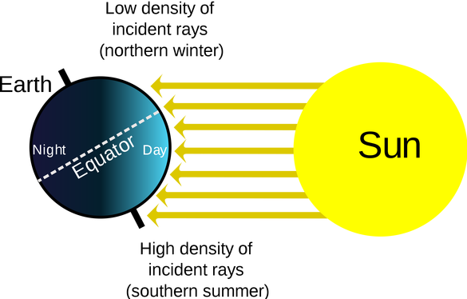
There are two major solar aspects that allow for seasons: the intensity of the Sun’s rays striking the Earth at higher angles (more direct at equator vs less direct at poles) and the length of daylight hours (more when you are tilted toward the sun, less when you are tilted away).

The tilt of Earth’s axis (23½ degrees) determines the amount of time that the Sun’s rays are penetrating on a portion of Earth, which essentially determines the length of days. If there weren’t a tilt in Earth’s axis, length of day would simply depend upon your latitude. Earth revolving around the Sun allows for different lengths of daylight because of different levels of exposure to the sun. This exists because the tilt remains at the same angle and points at the same direction (much like a fixed globe) as Earth revolves around the Sun, as seen in the image below. Click this link (http://cimss.ssec.wisc.edu/wxfest/Milankovitch/earthorbit.html ) to watch a simulation of Earth rotating around the Sun.

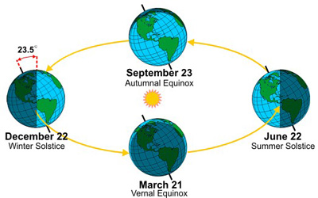
When the southern hemisphere is tilted towards the sun the northern hemisphere is tilted away from the sun and vice versa. If the tilt of Earth is toward the Sun, there is a longer length of day and the season is summer. If it is neither tilted toward or away from the Sun, the length of day and night is equal, which is the seasons of fall and spring. If the tilt of Earth is away from the Sun, there is a shorter length of day and the season is winter. Earth has seasons because its axis is tilted in the same direction as it moves around the Sun not because of any distance difference between the Sun and Earth. (Actually, there is a 1.5% difference from when Earth is closest to and furthest from the Sun, but Earth is actually furthest from the sun when North America is experiencing summer.)

Getting into Circulation
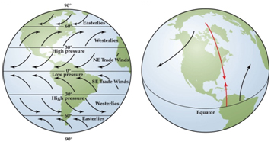
Circulation of the atmosphere is affected by the rotation, or spinning, of Earth on its axis because it causes the Coriolis effect. The Coriolis effect deflects winds that would otherwise blow directly from a high-pressure area toward a lower-pressure area from that path by causes the surface winds to turn. In the Northern Hemisphere, winds are deflected to the right and those in the Southern Hemisphere are deflected to the left.

Because convection cells are in place in the atmosphere and Earth is spinning on its axis, global winds are found in each convection region. Convection is the transfer of heat energy in fluids, liquids or gases, by the movement of the heated particles. In convection, particles with higher energy move from one location (warm) to another location (cold) carrying their energy with them. Because of Earth’s spherical shape, the Sun’s rays strike Earth more directly at the tropics than they do at the poles. At the poles, the same amount of solar radiation is spread over a larger area than at the equator. This unequal heating sets up the warmer-cooler regions necessary for global convection to take place in the atmosphere.

The air flowing from the warmer equator completes three looping patterns of flow called convection cells. There are three atmospheric convection cells in the northern hemisphere and three in the southern hemisphere.
- Tropical convection region: begins at the equator and extends to the about 30°N or 30°S latitude. At the equator, warm air rises at the equator, travels towards the 30°N/S then cools enough to descend at about 30 degrees latitude from which air flows both north and south. The cooler air now traveling along the ground is called the trade winds, and the blow from east to west as they continue to increase in temperature again. Trade winds are named by the direction they travel (eg. Southwest trade winds)

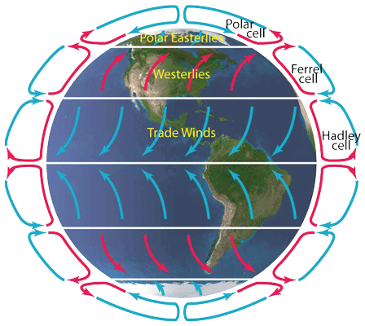
- Temperate convection region: extends from 30°N/S to about 60°N/S latitude. Descending air at 30°N/S moves either back toward the equator or toward the poles. If it moves towards the poles, the air at is warmed enough by the 60°N/S latitude to create a low pressure area that causes the air to rise again. This zone is affected most by the changing seasons. The winds traveling along the ground at in this region are called the westerly winds, and they blow from west to east. Since the United States is in the westerly wind belt, US weather systems move across this country from west to east. (Tropical storms and hurricanes are exceptions, as they originate in another zone. Tropical weather systems interact with the westerly winds, they are often change course drastically.)

- Polar convection region: extends from 60°N/S latitude to the poles, 90°N/S latitude. Air at the poles is descending cold air that moves toward the equator; at about 60°N/S it has warmed enough to begin rising. The major winds in this region are called polar winds, and they blow from northeast to west, moving cold air. When these polar winds meet the westerlies (at the 60°N/S latitude), a stormy region known as the polar front forms.

Local winds

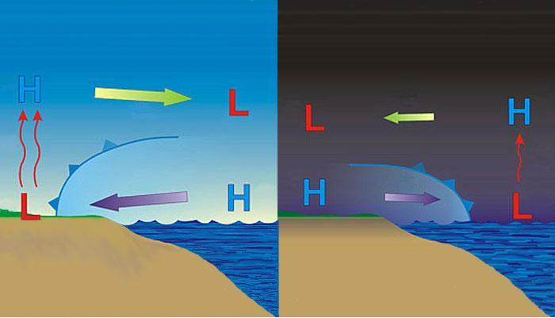
Temperature differences are the cause of these global circulation patterns, but that doesn’t mean that all wind in within those latitude markers are going to travel the same direction. Based on topography, land vs water, mountain vs valley, there are going to be different air temperatures and pressures within the same convection cell. On a regional scale, the concept is still the same; air travels from areas of high pressure to low pressure. Pressure is a measure of how close the molecules are to each other, so warm air is going to have lower pressure because the molecules are moving faster and are further apart. High-pressure air is usually cooler because the molecules have less energy and are packed closer together. This is why “hot air rises”.

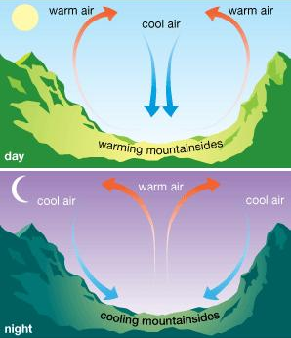
Land heats up more quickly than water does, and it cools more quickly than water does. Because of this, coastal areas will generally experience a sea breeze as colder air over a colder ocean travel inland to replace warmer air over a warmer land. This is why coastal regions are generally less extremely hot than areas that are many miles inland, because further inland does not experience these land breezes. Mountains and valleys act in a similar way, creating mountain and valley breeze as the mountain heats up before the valley can, causing low pressure at the top of the mountain, which pulls air from the valley.

At night, both of these processes reverse, as sea breeze travels out to the ocean because the land cools more quickly then the water, causing higher pressure over the land, which will move out to sea where lower pressures exist. Similarly, the mountain cools before the valley, causing higher pressure on the top of the mountain, which will force its way down into the valley where the warmer air had a lower pressure.

Check out this link (http://hint.fm/wind/) to watch wind patterns throughout the United States. Check out SC specifically. This means that winds are going to interact in a much more complex way than simply ‘East’ or ‘West’. This is where air masses and fronts come into play.

Review Questions
- What is the difference between rotating and revolving when talking about Earth?
- What are the two major solar factors that allow for seasons to occur on Earth?
- Does the Earth receive more direct solar rays at the equator or at the poles?
- What is important about the tilt of the Earth in terms of revolving around the sun?
- Imagine that it is currently winter in the Northern Hemisphere. Explain the relationship between the Earth and the Sun explaining which hemisphere is tilted towards/away from the Sun, which hemisphere is getting more direct rays, and which hemisphere is experiencing longer days.
- What is the basic idea of the Coriolis effect?
- What is convection, and what causes air (or water) to move from one location to another?
- List the 3 convection cells, the latitudes they exist between, the name of the major wind in that cell, the temperature of the air that major wind is transporting, and the direction the major wind is moving. (Hint: This would make a good table).
- 0°N/S, 30°N/S, 60°N/S, 90°N/S: List each one and if air is rising or dropping at that location.
- Explain what causes a sea breeze during the day.
- What happens to a sea breeze at night? Why?

