My Mineral Name Card
1. Look online for a mineral that begins with the first letter of your name. Geology.com is a good resource.
2. Print or draw a colored picture of the mineral that you chose.
3. Glue or tape the picture to a piece of colored paper.
4. Write the name of the mineral above the picture.
5. Write your name below the picture.
6. On the back of the card, write the physical properties about the mineral:
a. Chemical Classification
b. Color
c. Streak
d. Luster
e. Cleavage or Fracture
f. Moh’s Hardness
g. Chemical Composition
h. Uses
7. What physical properties of the mineral are similar to your personal traits? Highlight, box, or circle those properties.

EXAMPLE: Mrs. Mahon’s Mineral Choice
Front of Card | Back of Card
Topaz  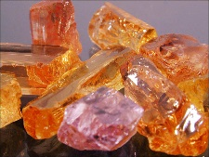  Tracey | Chemical Classification: Silicate  Color: Yellow, Orange, Pink  Streak: Colorless  Luster: Vitreous  Cleavage  Moh’s Hardness: 8  Chemical Composition: Al₂SiO₄(FOH)₂  Uses: Gemstone

