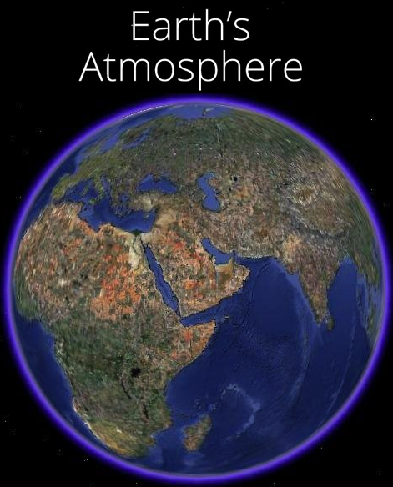
5.1.1 - How Does the Atmosphere Work?
Background: Recall back to when we looked at Earth’s internal composition, Earth has a radius of ~6700km from the center of the inner core to the outside of the crust. The atmosphere however, is technically only about 100km thick, which means it is about 1.5% as thick as Earth, which means the image to the right actually shows the atmosphere as too thick.

Earth’s atmosphere is the layer of gases (a mixture of chemical elements and compounds) that surrounds the planet and makes conditions on Earth suitable for living things. Earth is not the only planet that has an atmosphere, but it is easily the most relevant to us currently. Earth’s atmosphere is composed of 5 layers, with each of the layers being defined by distinct differences in temperature with increasing altitude.

Earth’s atmosphere is divided into 5 atmospheric layers Earth’s surface outward: troposphere, stratosphere, mesosphere, thermosphere, and exosphere. Each layer has different composition, properties, and temperature characteristics. The image to the left shows the layers of Earth’s atmosphere to scale compared to each other.

Troposphere (0 km – 12 km)
The troposphere is the layer where all weather occurs. Air molecules are heated by surface temperatures, heating up the air closest to the surface, causing hot air to rise, leading to vertical convection currents. The air closest to us is also the warmest, as the atmosphere is mostly heated by the land and the sea, not by the sun. These convection currents are the basis of weather. Temperatures in this layer decrease as you travel further away from Earth’s crust. 80% of the mass of the entire atmosphere is found on this layer, and it is only this thin because of the pressure of the other layers pressing down upon it. The top of the troposphere is called the tropopause, and at this point, temperatures stop decreasing.

Stratosphere (12 km – 50 km)
The stratosphere is the layer where the ozone layer (O₃) is found. The ozone is found from 20km-30km from the Earth’s surface (on average) and protects the Earth from harmful ultraviolet rays from the Sun. It does this by absorbing these UV rays, causing the top of the stratosphere to be hot. The rest of the stratosphere below the ozone layer is cold, about the same temperature as the tropopause. At this level, the air pressure is about 0.1% of the air pressure at sea level. There are no clouds and no weather here, however the ozone layer causes the stratosphere to be very stable. This is the highest layer that jets can fly in because the air pressure gets to low in higher layers. This is also the level that the highest manned balloon flight has been, reaching ~41 kilometers in altitude in 2014 (by a Google senior VP). The stratopause is the upper boundary of the stratosphere.

Mesosphere (50 km – 80 km)
The mesosphere is the coldest layer, with temperatures decreasing as the altitude increases. This layer is too high for jet engines, but too low for orbiting satellites. Meteors burn up in this layer.

Thermosphere (80 km – 700 km)
At this point, the air pressure is low enough that particles may travel for over 1 kilometer before hitting another particle (compared to sea level, where there are billions of billions of gas particles in every breath. Even though the air is incredibly thin, the thermosphere is very hot, with temperature increasing as altitude increases.
- 100 km – The “End of the Atmosphere” – Arbitrarily assigned in the 1950s. Which means everything above this altitude is actually considered “space.”
- 120 km - This is the first altitude where the atmosphere is noticeable upon reentry to Earth’s atmosphere.
- 350-420km – This is the altitude of the International Space Station Orbit

Exosphere (700 km – 10,000 km)
Cold regions of outer space extend from here. Molecules are up to 100s of kilometers apart. Most of Earth’s satellites orbit in this layer.
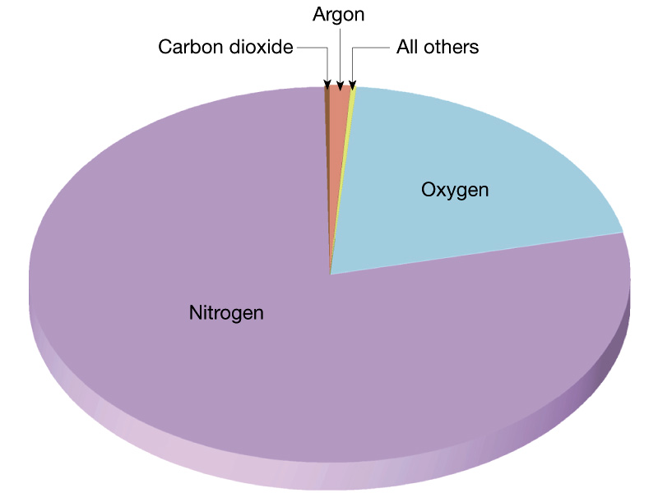
Atmospheric Composition
Earth’s atmosphere is made up a few specific gasses. Nitrogen (N₂) makes up 78% of the atmosphere, while Oxygen (O₂) makes up 21% of the atmosphere. Both of these gasses are found throughout all the layers. Argon makes up 1% of the atmosphere, but it plays no significant role to life on Earth.

Water vapor (H₂O) makes up ~0.5% of the atmosphere, while carbon dioxide (CO₂) makes up 0.039% of the atmosphere. These two compounds are the most important compounds in the atmosphere because they drastically affect weather conditions and are both mostly found in the troposphere. These are two of the major greenhouse gasses, which are gasses that absorb and emit infrared radiation. Water vapor (H₂O), carbon dioxide (CO₂), methane (CH₄), nitrous oxide (N₂O), ozone (O₃), chloroflourocarbons (CFCs) make up the most abundant greenhouse gasses in Earth’s atmosphere. Each of these greenhouse gasses are found in very small concentrations, less than 1% of the total atmosphere combined, but they have a profound effect on global climate. Without these gasses, Earth’s average surface temperature would be 0°F, compared to the current 59°F average surface temperature.

Greenhouse effect
Check out this simulation for a quick look at how the greenhouse effect works.
http://environment.nationalgeographic.com/environment/global-warming/gw-overview-interactive/

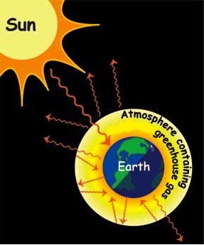
It is natural for Earth’s atmosphere to trap heat in the troposphere; this is known as the greenhouse effect. The Earth gets energy from the sun in the form of sunlight. There is a delicate balancing act occurring every day all across the Earth, involving the radiation the planet receives from the Sun (visible light, ultraviolet, infrared, etc…) and the radiation that's reflected back out to space. About 30% of the radiation is immediately reflected back out to space by clouds, ice, snow, sand, and other reflective surfaces. The remaining 70% of the solar radiation is absorbed by oceans, land, and the atmosphere. This is why sand or cement gets very hot in the summer. As they heat up, the oceans, land, and atmosphere release heat through the atmosphere and back into space in the form of infrared thermal radiation. This is shown in the image to the right with the arrows exiting Earth’s atmosphere.

Greenhouse gasses, such as CO₂, H₂O, CH₄, N₂O, and O₃, stop some of this infrared thermal radiation from exiting back to space, and actually reflect them back to Earth’s surface. This “trapping” of thermal radiation is what keeps Earth’s troposphere and crust warm, compared to Mars or the Moon, which reach temperatures as low as -153°F on the surface because they lack an atmosphere that traps any heat. The same process occurs in cars in the summer, with the windows performing the same actions as the greenhouse gasses. They let solar radiation in, but then prevent some of the thermal radiation from escaping. This is shown in the image to the right as some arrows get reflected off the atmosphere and directed back to Earth.

Review Questions
- List the 5 different layers of atmosphere, at what distances you find that layer (0km – 12km as an example), and what happens with the temperature as you increase altitude in that layer. (Hint: This would make a nice table)
- What are the uppermost portions of the troposphere and the stratosphere called?
- Where is most of the mass of the atmosphere found? How much of it is found in this layer?
- How far up, and in which layer, does the atmosphere “end”?
- In which layer does all weather exist?
- What layer do convection currents exist in, briefly explain convection currents, and explain what actually warms up the air?
- Which layer is the ozone layer found within and how far away is it from Earth’s Surface?
- What is the purpose of the ozone layer?
- What are the 2 most common gasses found in the atmosphere, and what are their respective concentrations?
- List at least 6 major greenhouse gasses found in the atmosphere (name and chemical formulas).
- Briefly explain the greenhouse effect.

